**In this project I made simple site with database access feature for login and logout. In project I used HTML, CSS, JS for frontend design, Python Django for backend and sqlite for database connectivity.**

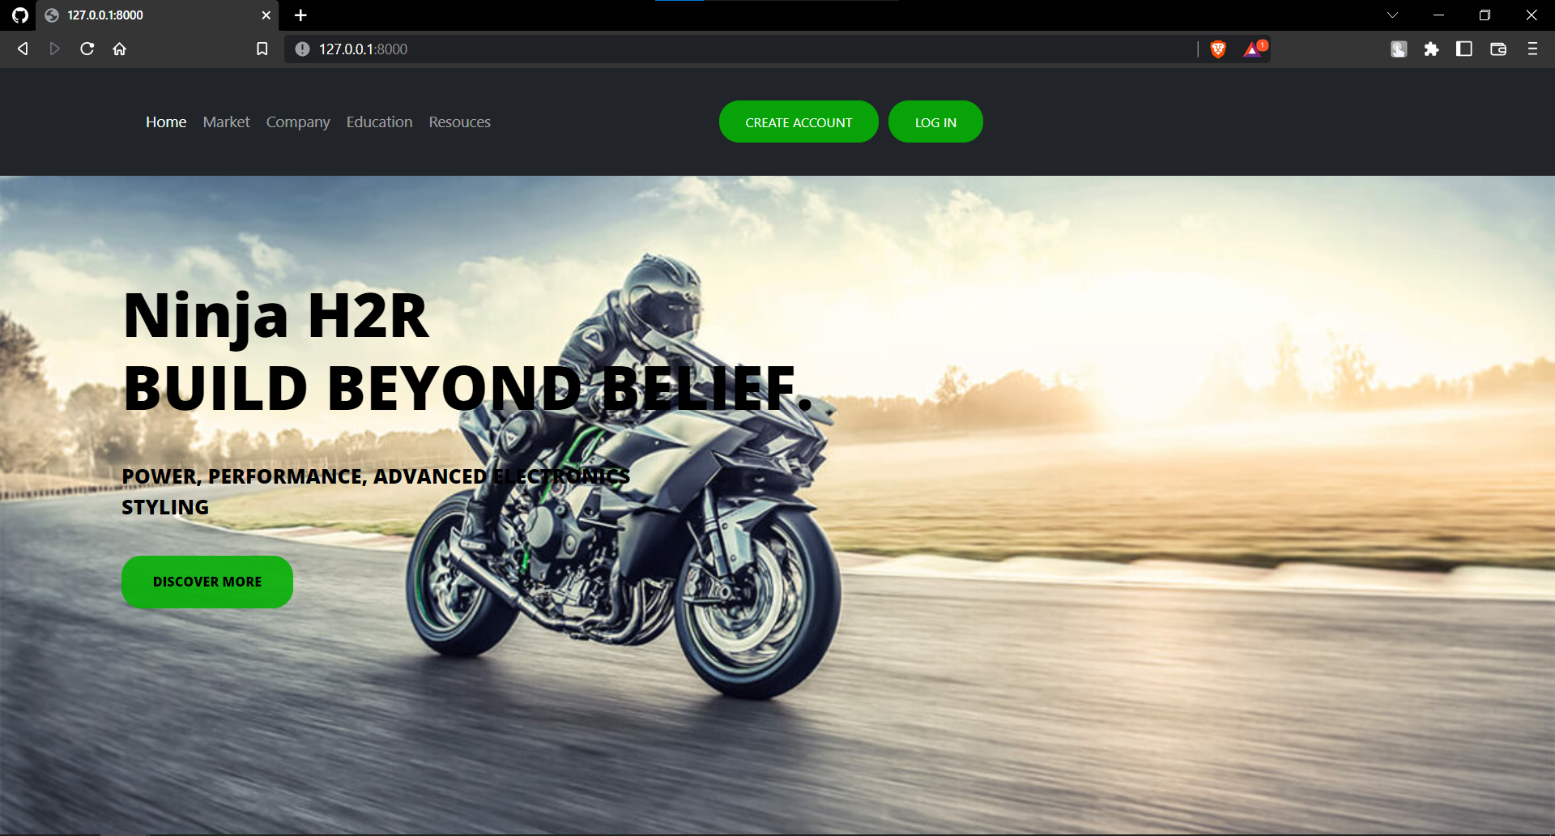

**The above given image is homepage to my site with login and signup function**

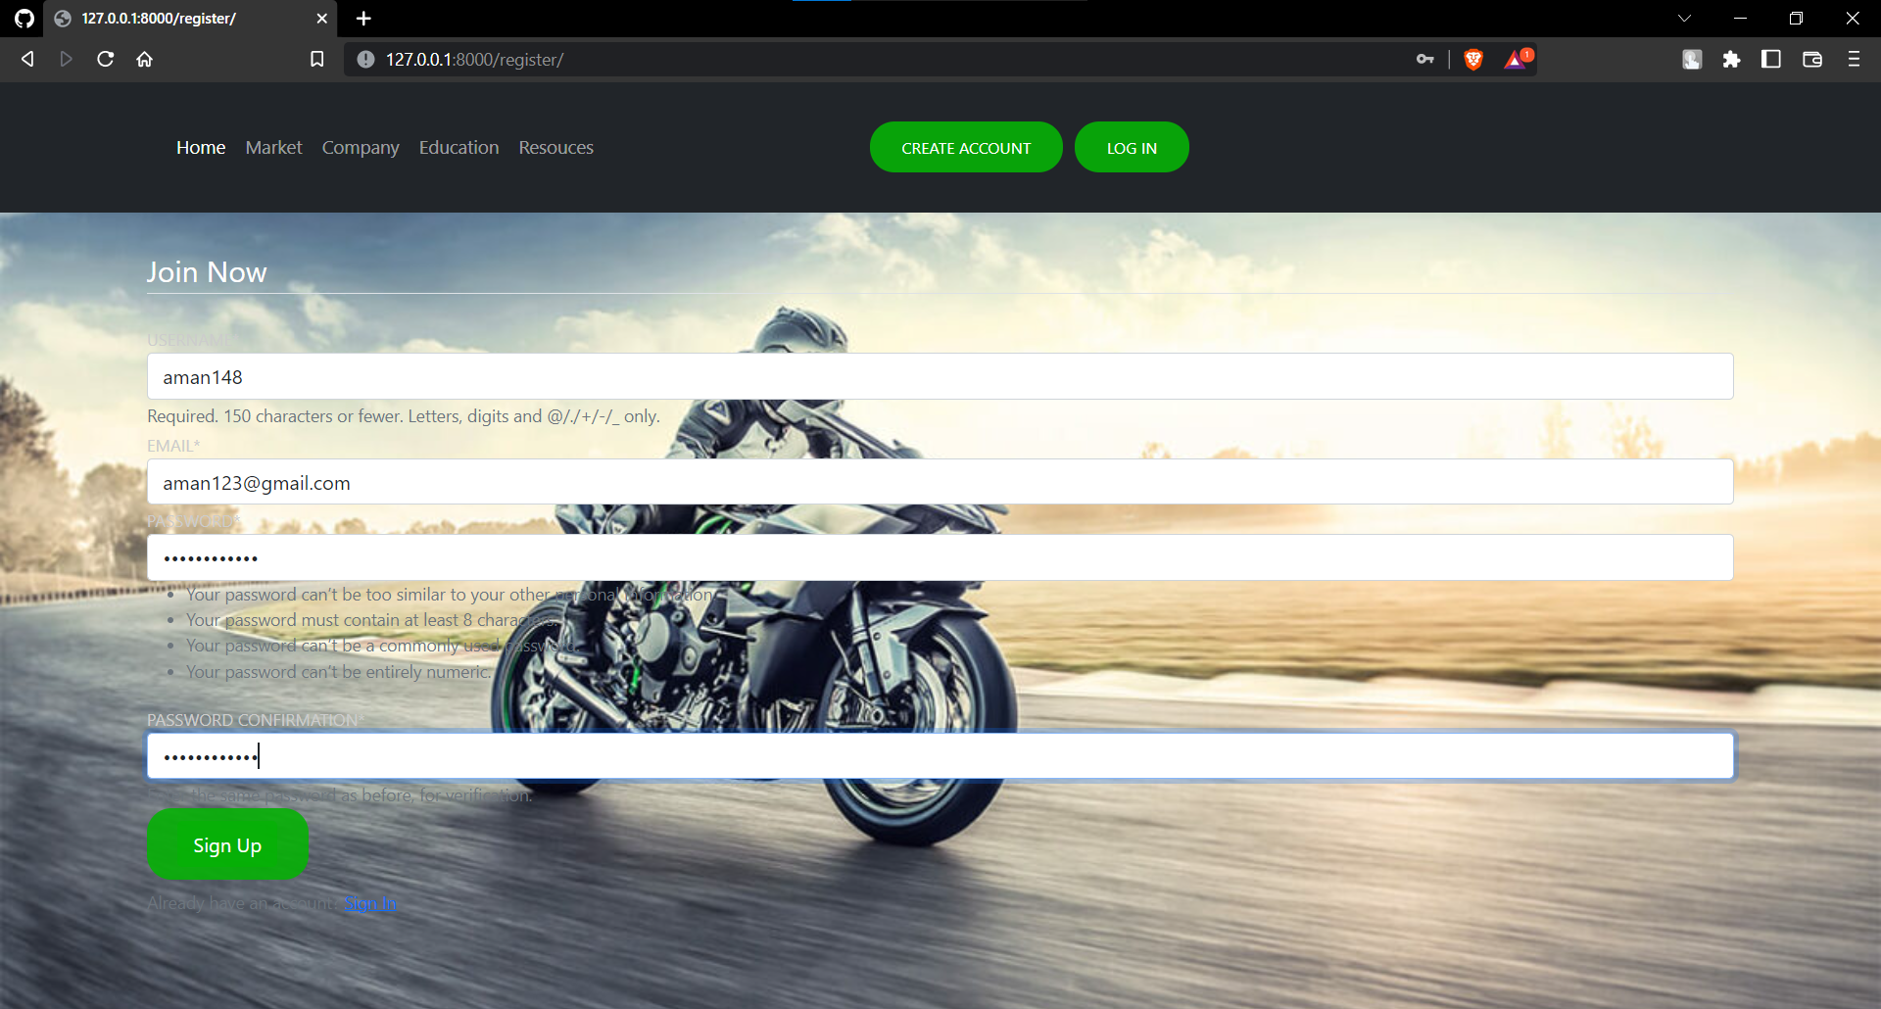

**The above given page is creating a new account with the username of aman148. This site is connected to data through python Django and data sqlite database is used with it. Sqlite data comes by default with Django**

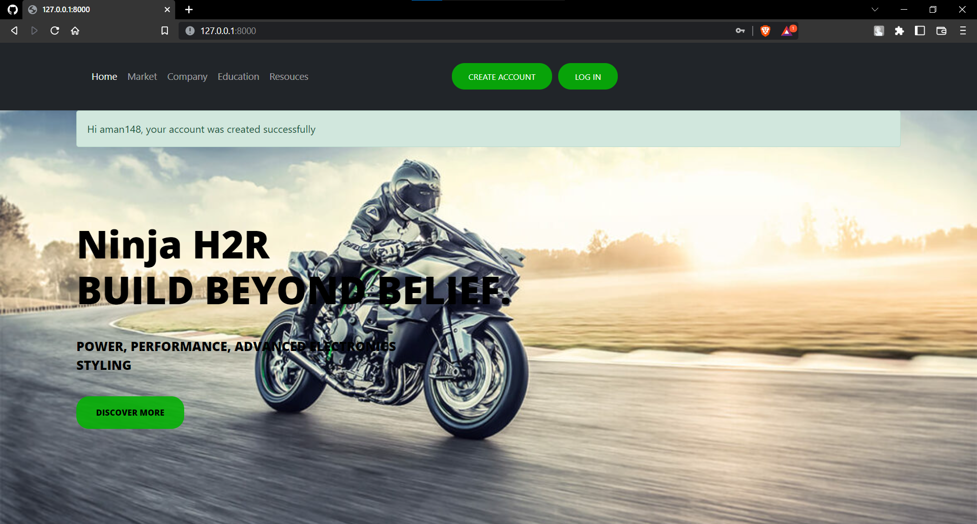

**In above image i made account successfully with username aman148 which I given in earlier image.**

**This username and password is saved in database so now I can login with this credential. To make successful login I have give same username and password if anyone in these give false information then I am not able to login in it.**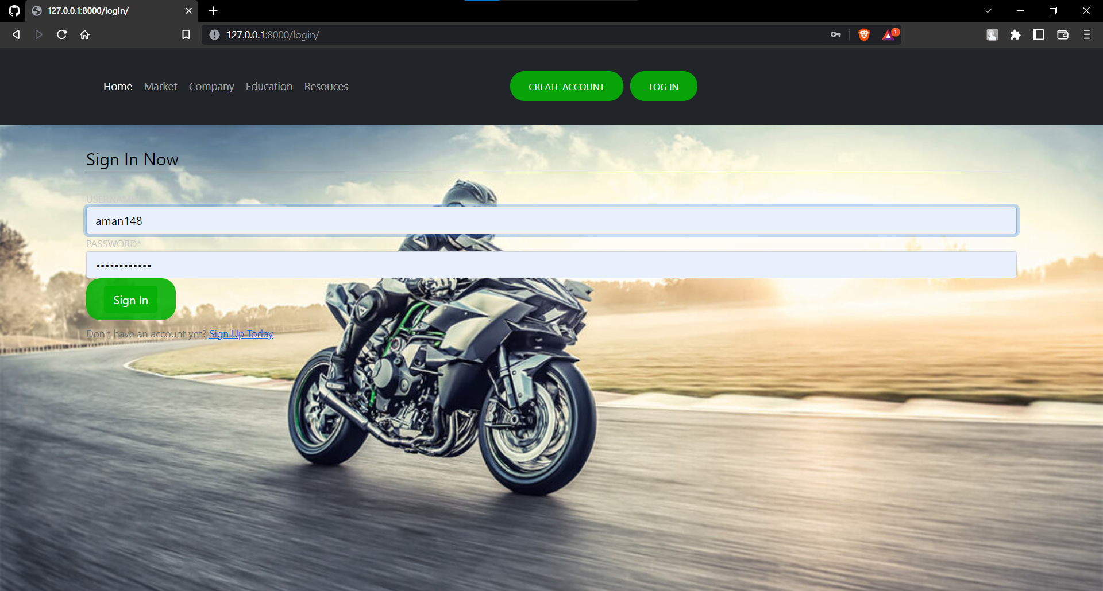

**Here I am providing the same credential which I given earlier to make successful login.**

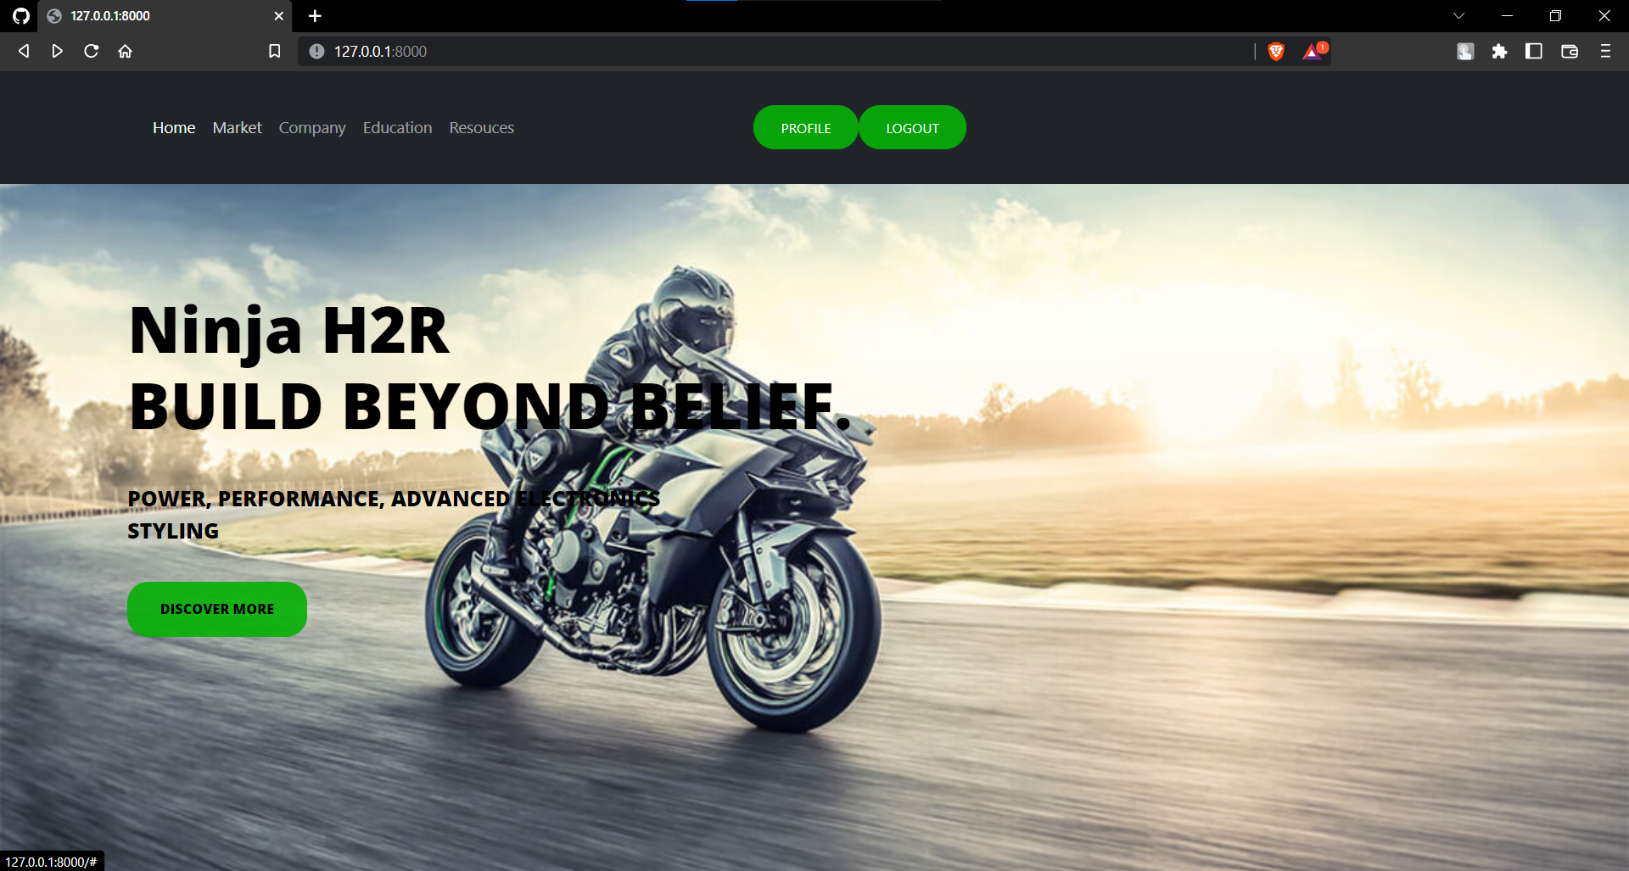

**After making a successful login header information changed now it is showing profile and logout function which indicate we made a successful login**

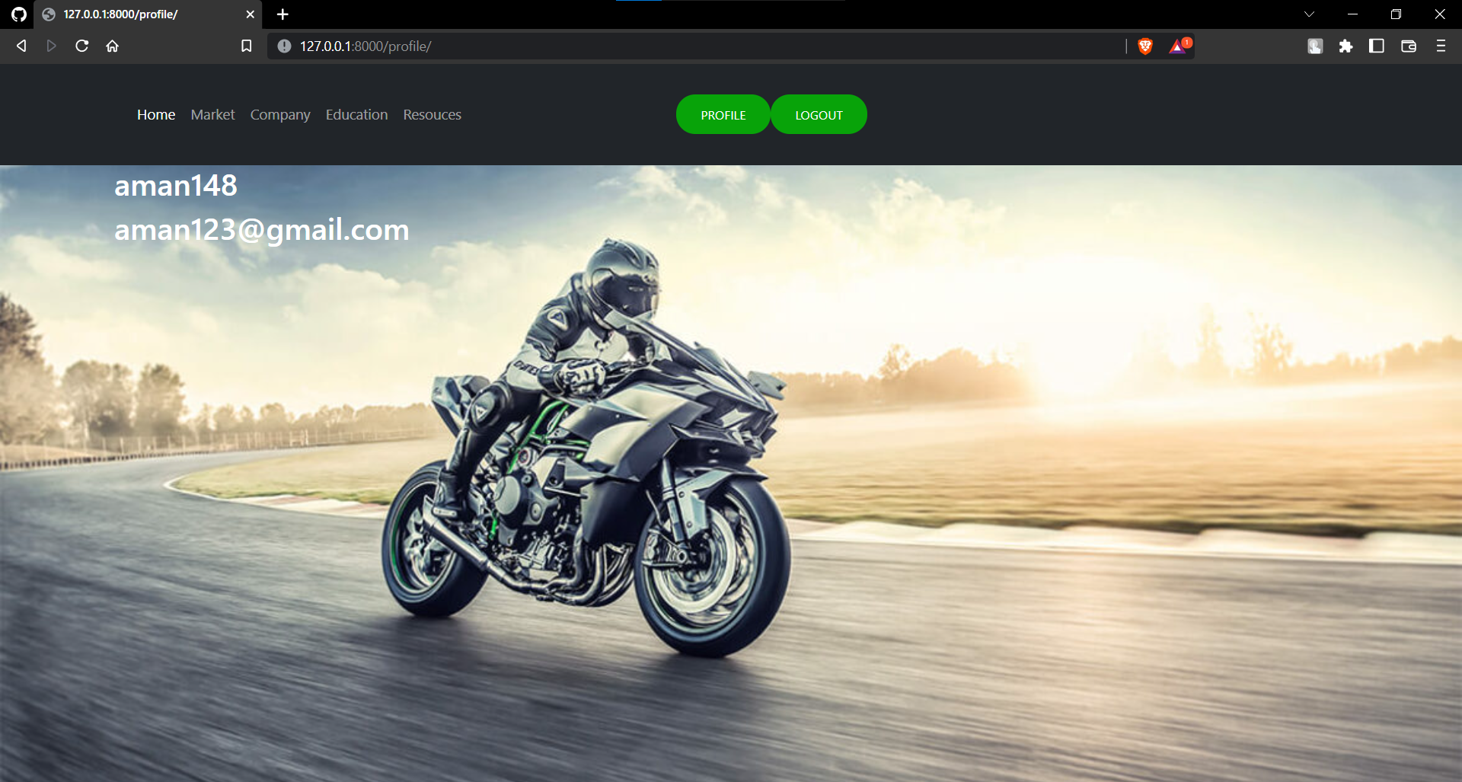

**After login if we comes under the profile section then we can see the username and email address through which we make a login**

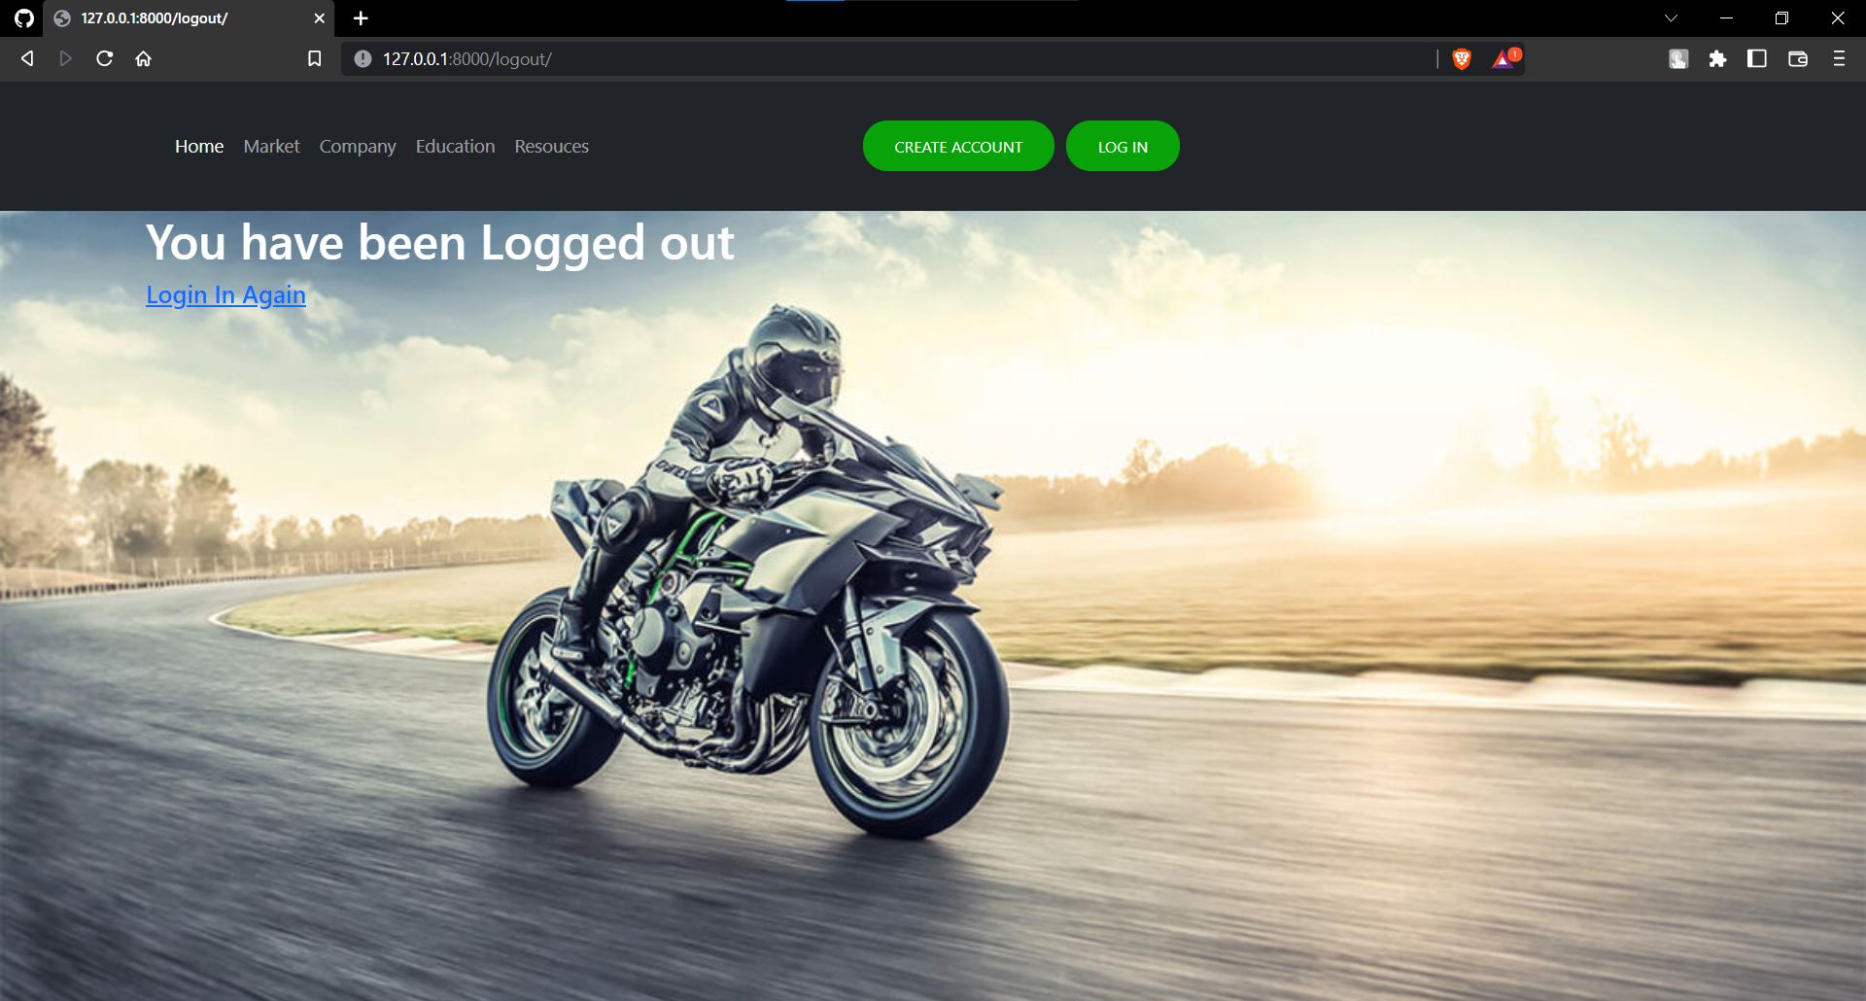

**Here we can see what will happened if we logout form our account**